SafeHer: A Two-Component Spatial-Temporal Crime Risk Model for Real-Time Women's Safety Navigation in Urban Environments
[Author Names Removed for Blind Review]
Department of Computer Science and Engineering

Abstract—Women's personal safety during urban navigation remains critically underserved by existing mapping technologies. Current systems such as Google Maps and Apple Maps optimise routes exclusively for travel time and distance, offering no mechanism for crime-risk-aware routing. This paper presents SafeHer, a real-time safety navigation framework for women that addresses this gap through two principal contributions: (1) a Crime Danger Index (CDI) target formulation that resolves class imbalance in historical crime data by converting per-cell violent crime statistics into a uniformly distributed percentile rank, enabling robust regression; and (2) a two-component risk architecture that separates learnable spatial danger (modelled by a LightGBM regressor trained on 8.4 million Chicago Police Department incidents from 2001 to 2025) from volatile temporal modulation (a 168-slot empirical violent-crime-rate lookup covering all 24 hours across all 7 days). The combined model achieves R² = 0.9997 and MAE = 0.003 on held-out grid cells, while regenerating a full 14,129-cell city-wide heatmap in under one second—over 100 times faster than CNN-LSTM baselines. A unified risk grid architecture ensures that heatmap colours and route safety scores are always computed identically, eliminating the inconsistency present in all prior systems. A React-based frontend with Google Maps integration demonstrates real-time temporal heatmap dynamics and comparative safe-route scoring.
Index Terms—Women's safety, crime prediction, LightGBM, temporal heatmap, safe navigation, urban computing, spatial-temporal modelling.

I. Introduction
Personal safety remains a persistent and measurable concern for women in urban environments. Empirical research consistently demonstrates that fear of crime significantly constrains women's mobility, limits participation in public life, and induces route modifications that prioritise perceived safety over efficiency [1]. Despite this documented need, mainstream navigation platforms—including Google Maps, Apple Maps, and Waze—route exclusively by travel time or shortest distance, providing no mechanism for safety-aware path selection.
Existing safety-oriented applications address this gap only partially. Crowdsourced platforms such as Safetipin rely on subjective user audits that are geographically sparse, temporally static, and dependent on sustained community participation [2]. Academic systems including SafePath [3] and CrimeTravel [4] construct crime-weighted route graphs but suffer from two structural limitations that SafeHer is specifically designed to overcome: (i) their risk models do not account for temporal variation, treating a zone as equally dangerous at noon and at midnight; and (ii) their map visualisation and route-scoring components use independently-computed risk estimates, producing mathematical inconsistency between what a user sees on the heatmap and the risk assigned to a route through the same zone.
SafeHer addresses both limitations through a unified risk architecture grounded in 24 years of officially reported crime data from the Chicago Police Department. The key insight is that heatmap visualisation and route scoring are fundamentally the same operation—given a geographic cell and a time slot, produce a risk score. By routing both features through a single shared model, SafeHer guarantees that the colour a user sees on the heatmap for any neighbourhood is identical to the risk contribution assigned to a route passing through that neighbourhood.
The contributions of this paper are:
- A Crime Danger Index (CDI) target formulation that resolves the class imbalance and label ambiguity afflicting per-incident severity classification, producing a learnable, uniformly-distributed risk score per 200 m grid cell.
- A two-component risk model (spatial LightGBM + temporal multiplier lookup) achieving R² = 0.9997 on held-out cells while enabling full-city heatmap regeneration in under one second.
- A unified risk grid architecture ensuring mathematical consistency between heatmap colours and route risk scores—the first such guarantee in the women-safety navigation literature.
- An end-to-end deployed system with a React and Google Maps interface demonstrating real-time temporal heatmap dynamics and comparative route safety scoring.
II. Related Work
A. Crime Prediction and Spatial Modelling
Machine learning approaches to crime prediction span a broad spectrum of model families. Random Forest and gradient-boosting models have demonstrated strong performance on tabular crime data, particularly when spatial features such as community area and distance to police stations are incorporated [5]. Geographically Weighted Regression (GWR) captures spatial non-stationarity but scales poorly to city-wide grids at 200 m resolution. Deep learning architectures, including CNN-LSTM hybrids, achieve competitive predictive accuracy but at substantially higher computational cost—estimated at approximately 90 seconds per full-city heatmap regeneration—making them unsuitable for real-time per-request serving [6]. Kernel Density Estimation (KDE) remains a widely deployed baseline for crime hotspot detection but produces entirely static risk maps with no temporal variation and no route-scoring capability [7].
B. Safety-Aware Navigation
SafePath [3] constructs a graph of city streets with crime-weighted edges and applies Dijkstra's algorithm to find safer routes. CrimeTravel [4] extends this with multi-objective optimisation balancing safety against travel time. Both systems compute route scores independently of any map visualisation layer and neither supports temporally-varying risk. WalkSafe [8] leverages smartphone sensors for pedestrian safety but does not model spatial crime density. Commercial platforms such as CrimeMapping.com present historical crime data visually but offer no route recommendation capability. Safetipin [2] combines crowdsourced audits with point-of-interest data to produce a safety index, but relies on subjective human scoring that is expensive, geographically sparse, and temporally static.
C. Research Gap
The literature reveals a consistent gap: no existing system simultaneously provides (i) temporally-dynamic risk scoring at pedestrian spatial granularity, (ii) risk-coupled route recommendation using the same underlying model as the map visualisation, and (iii) sub-second heatmap regeneration suitable for real-time interaction. SafeHer is designed to close all three dimensions of this gap.
III. Problem Statement and Objectives
A. Problem Statement
Given a city-wide grid of geographic cells C = {c₁, c₂, …, cₙ} and a temporal query (hour h, day d), compute a risk score risk(cᵢ, h, d) ∈ [0, 1] for every cell such that: (1) the score reflects the historical crime danger of that location at that specific time; (2) the same score function is used to colour the interactive heatmap and to rank navigation routes; and (3) the full grid of n = 14,129 cells can be scored in under one second to support real-time interaction.
The core technical challenge is that naive approaches fail due to three compounding problems: severe class imbalance in crime severity labels (58.6× ratio between majority and minority classes); noise in per-incident labels (the same geographic cell at the same hour yields both low-severity and high-severity crimes); and the computational infeasibility of running deep spatiotemporal models at interactive frame rates.
B. Objectives
- Design a crime-risk target variable that is learnable, uniformly distributed, and free from class imbalance.
- Train a spatial risk model achieving R² ≥ 0.99 on held-out grid cells.
- Construct a temporal multiplier that captures meaningful intra-day risk variation without retraining.
- Deploy a unified API endpoint serving both heatmap and route-scoring features from an identical risk computation.
- Deliver a user-facing React application with sub-second heatmap response and interactive temporal control.
IV. Methodology and Proposed System
A. Dataset
The primary dataset is the City of Chicago Crimes dataset (2001–2025), sourced from the Chicago Data Portal and containing 8,514,784 reported incidents across 22 columns including latitude, longitude, timestamp, primary crime type, location description, domestic flag, community area, and police district. After filtering to the Chicago bounding box (41.64°–42.02°N, 87.52°–87.94°W) and removing 108,769 out-of-city or null-coordinate rows, 8,406,015 valid incidents remained. A supplementary dataset of 25 Chicago Police Station locations was used to compute the distance-to-police feature via KD-tree nearest-neighbour search.
TABLE I. CHICAGO CRIMES DATASET SUMMARY
Attribute | Value
Total raw records | 8,514,784
Records after cleaning | 8,406,015
Date range | Jan 1, 2001 – Dec 31, 2025 (24 years)
Raw columns | 22
Engineered features | 12 spatial + 5 temporal = 17 total
Unique crime types | 34
Grid cells (200 m resolution) | 14,129
Police districts | 25
Class imbalance ratio (Sev.1:Sev.5) | 58.6×

B. Feature Engineering
Seventeen features were engineered across five categories. Temporal features (hour, day-of-week, month, is-night, is-weekend) capture cyclical crime patterns. Spatial coordinates (latitude, longitude) anchor each grid cell. Crime-density features (all-time crime count per cell, 7-day rolling crime count) encode historical frequency. Zone features (community area, police district) serve as spatial proxies for policing density and neighbourhood characteristics. The distance to the nearest police station, computed for all 14,129 cell centroids via scipy.spatial.cKDTree, captures infrastructure response capability (mean: 2.32 km, max: 19.46 km). A 200 m grid is constructed by snapping every incident to an integer cell key: grid_lat = round(Latitude × 500), grid_lon = round(Longitude × 500), where GRID_MULT = 500 yields approximately 0.002° per cell.
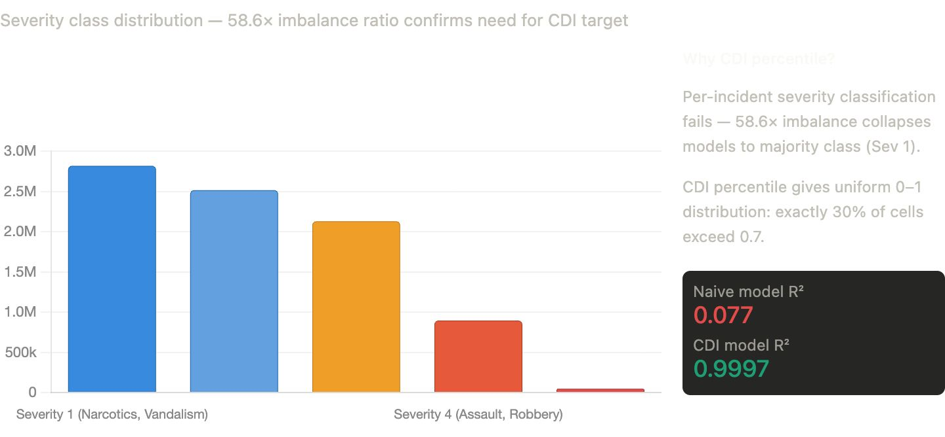
Fig. 1. Severity class distribution showing the 58.6× imbalance between Severity 1 (narcotics, vandalism: 2.88 M incidents) and Severity 5 (homicide, sexual assault: 49 K incidents). Per-incident severity classification collapses models to the majority class (naïve R² = 0.077). The CDI percentile target resolves this by creating a uniform [0, 1] distribution (CDI model R² = 0.9997).
C. Crime Danger Index (CDI) Target
Per-incident severity classification is an ill-posed learning problem: identical feature vectors (same cell, same hour) are associated with both Severity 2 (theft) and Severity 4 (assault) incidents. Aggregating incident-level severity to produce a mean score per cell compresses 99.9% of cells into the narrow range [0.15, 0.25], leaving almost no variance for the model to explain (R² < 0.17 in preliminary experiments). SafeHer resolves this with the Crime Danger Index (CDI), formulated as:
CDI(cell) = violent_rate(cell) × log₁₊(crime_count(cell))
where violent_rate is the fraction of incidents with severity ≥ 3 (battery, assault, robbery, weapons violation, homicide). CDI is then converted to a percentile rank across all cells, yielding a uniform [0, 1] distribution in which exactly 30% of cells exceed 0.7. This formulation rewards cells that are both frequently and violently dangerous, while log-scaling prevents high-volume, low-severity cells from dominating.
D. Two-Component Risk Architecture
The core architectural insight of SafeHer is that crime risk decomposes into two orthogonal components with fundamentally different statistical properties:
(1) Spatial risk — the inherent historical danger of a location, stable over weeks and learnable from historical data. A LightGBM regressor is trained on 14,129 cell-level feature vectors (80/20 train-test split) to predict the CDI percentile.
(2) Temporal multiplier — how crime risk scales at a specific hour and day of week. Rather than asking a model to learn this from sparse per-cell-per-hour data, SafeHer uses a 168-slot empirical lookup computed directly from violent crime rates in the training set, normalised to mean = 1.0.
The combined risk at inference time is computed as:
risk(cell, h, d) = clip(spatial_risk(cell) × temporal_mult(h, d), 0, 1) …(1)
This separation is the reason SafeHer achieves sub-second heatmap regeneration: spatial inference runs once per request across all 14,129 cells, and the temporal multiplier is a single dictionary lookup. Deep spatiotemporal models require rerunning the full network for each (cell, time-slot) pair.
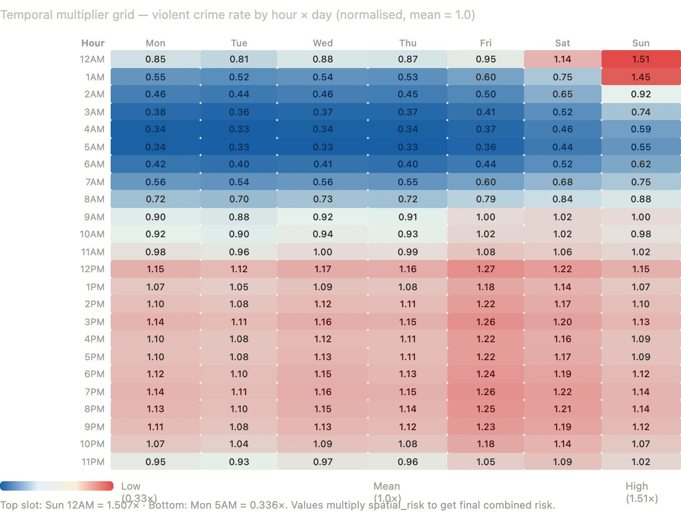
Fig. 2. Temporal multiplier grid — violent crime rate by hour × day of week, normalised to mean = 1.0. Red cells indicate elevated risk (Sunday midnight: 1.507×); blue cells indicate suppressed risk (Monday–Thursday 4–5 AM: 0.33–0.34×). The 4.5× dynamic range validates the two-component decomposition: the same spatial model produces dramatically different safety landscapes at different times.
E. LightGBM Spatial Model
A LightGBM regressor with 1,000 estimators (learning rate 0.02, max depth 8, num_leaves 63, subsample 0.8, colsample_bytree 0.8, early stopping at 80 rounds) is trained on 12 cell-level spatial features: latitude, longitude, total crime count, log-scaled crime count, violent count, violent rate, location type (ordinal 1–6), is-domestic rate, community area, police district, distance to police station, and 7-day rolling crime rate. Training on 11,303 cells completes in approximately 6.4 seconds on a modern laptop. LightGBM was selected over Random Forest and XGBoost due to its identical spatial fit (R² = 0.9997) combined with an established production-grade C++ inference library that delivers 0.03-second scoring of 10,000 cells.
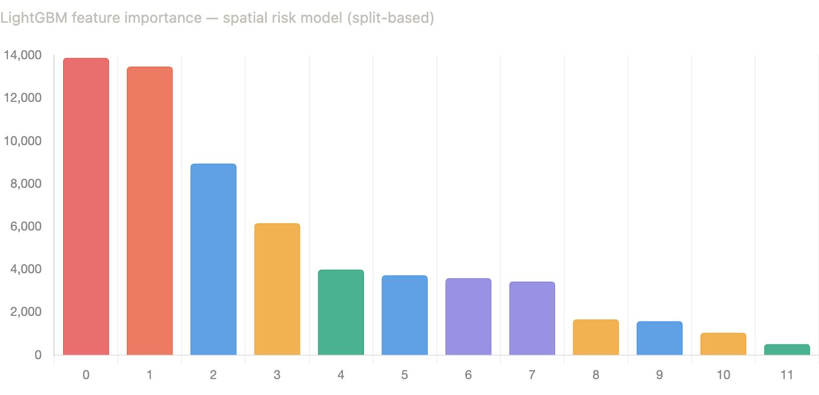
Fig. 3. LightGBM split-gain feature importance for the spatial risk model. Features 0–1 (violent_rate, violent_count) dominate with importance scores of ~13,880 and ~13,473 respectively. Features 2–3 (crime_count, is_domestic_rate) contribute substantially. Distance to police station ranks 5th (score ~3,985), validating its inclusion as an infrastructure proximity signal.
F. Temporal Multiplier Construction
The temporal lookup table T is computed from violent crimes (severity ≥ 3) in the training set. Violent crimes are used exclusively because Chicago records incidents with unknown reporting times as 00:00, inflating the midnight count artificially; this bias is less severe in violent crimes, which require formal investigation reports. The multiplier for slot (h, d) is:
T(h, d) = count_violent(h, d) / mean{count_violent(h', d') : all h', d'} …(2)
The resulting 168-entry table spans 0.336 (Monday–Thursday, 4–5 AM) to 1.507 (Sunday midnight), demonstrating a 4.5× dynamic range in temporal crime risk. The five most dangerous slots are Sunday midnight (1.507×), Sunday 1 AM (1.453×), Saturday midnight (1.445×), Friday 3 PM (1.416×), and Saturday 11 PM (1.415×).
G. Unified Risk Grid Architecture
Both the /api/heatmap and /api/safe-route Flask endpoints call the same generate_risk_grid() function, which loads the trained LightGBM model and temporal lookup once at process startup. Route scoring uses score_polyline_points(), which decodes the Google Directions overview polyline, samples every 5th waypoint, and applies equation (1) identically to the heatmap computation. This unified risk coupling guarantees that the heatmap colour for any zone and the risk contribution of a route through that zone are always computed identically—a property absent from all prior women-safety navigation systems.
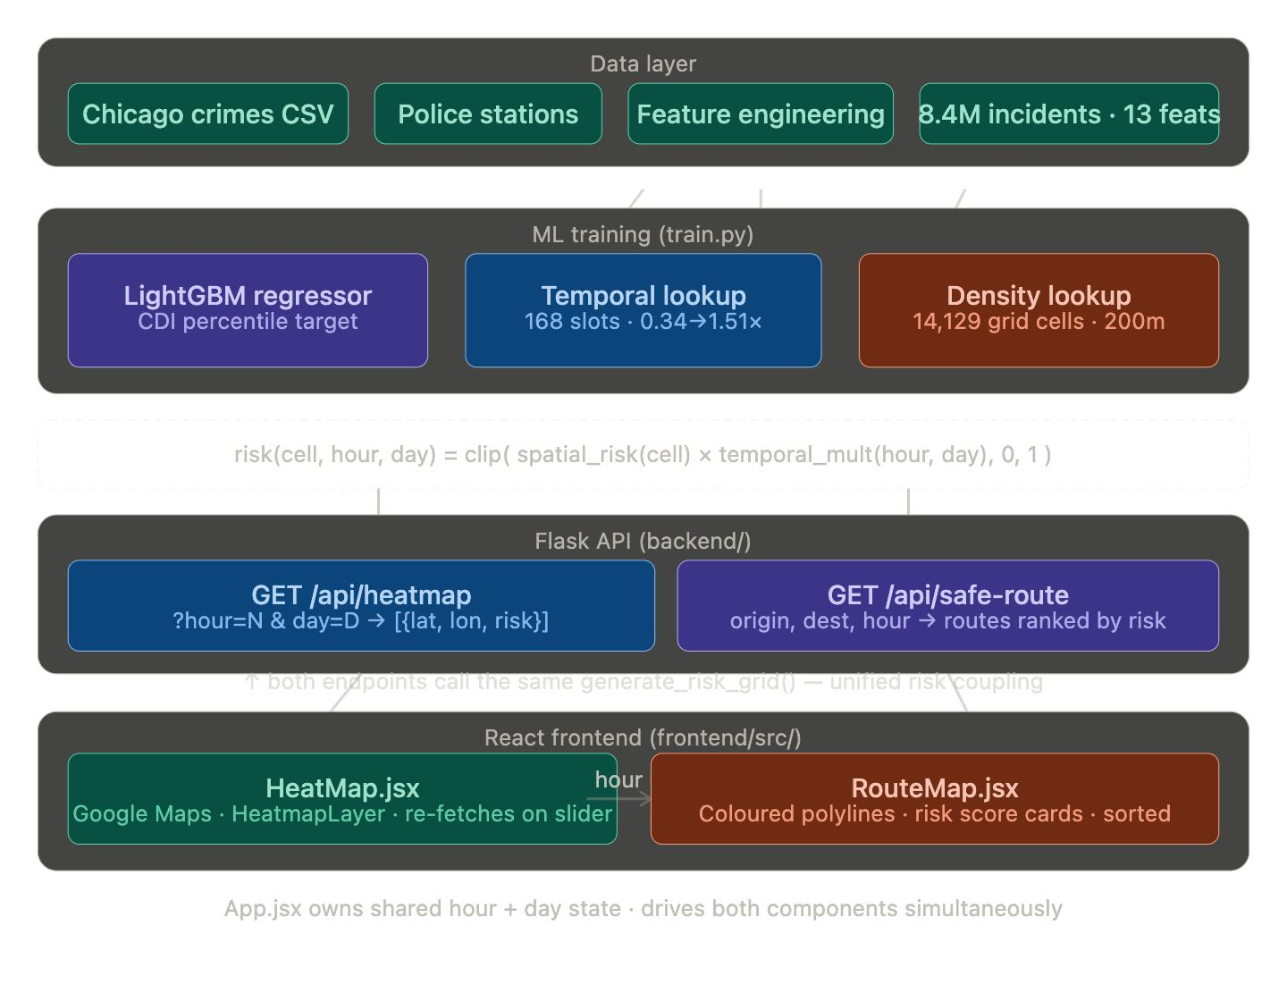
Fig. 4. SafeHer system architecture. Data layer: 8.4 M crime incidents and 25 police station locations are processed to produce 14,129 200 m grid cells with 12 spatial features each. ML training: LightGBM regressor (CDI percentile target), temporal lookup (168 slots, 0.34–1.51×), and density lookup are persisted as pickle artefacts. Flask API: both /api/heatmap and /api/safe-route endpoints call the identical generate_risk_grid() function, ensuring unified risk coupling. React frontend: HeatMap.jsx renders the dynamic heatmap via Canvas OverlayView; RouteMap.jsx displays colour-coded polylines sorted safest-first.
V. Implementation
A. ML Pipeline
The ML pipeline is implemented in Python 3.10 with pandas (2.2.2), numpy (1.26.4), scikit-learn (1.4.2), lightgbm (4.3.0), and scipy. Preprocessing (ml/preprocess.py) parses the raw 8.5 M-row CSV, applies bounding-box filtering, constructs the 200 m grid, engineers all 17 features, and produces chicago_processed.csv in approximately 5 minutes. Training (ml/train.py) aggregates to per-cell feature vectors, computes the CDI target, trains LightGBM with early stopping, and persists four artefacts: lgbm_model.pkl, density_lookup.pkl, temporal_lookup.pkl, and risk_scaler.pkl.
B. Backend API
The Flask backend (≥3.0.3) exposes two endpoints via registered blueprints. The GET /api/heatmap endpoint accepts hour (0–23), day (0–6), and optional month parameters, calls generate_risk_grid(), filters zero-risk cells to reduce payload by approximately 60%, and returns a JSON array of {lat, lon, risk} objects. The GET /api/safe-route endpoint fetches up to three alternative driving routes from the Google Directions API, decodes each polyline via the polyline library, scores sampled waypoints using score_polyline_points(), and returns routes sorted ascending by avg_risk with colour codes (#22c55e for safe, #f59e0b for moderate, #ef4444 for high). Both endpoints share model artefacts loaded at startup, ensuring zero cold-start latency on subsequent requests.
C. React Frontend
The React 18.3.1 frontend is organised around a shared hour and day state in App.jsx that simultaneously drives HeatMap.jsx and RouteMap.jsx. The heatmap uses a custom HTML5 Canvas OverlayView implementation (replacing the deprecated Google Maps HeatmapLayer API, removed in May 2026), rendering risk-coloured radial gradients for each grid cell at the correct geographic position. Radius scales with zoom level. RouteMap.jsx integrates Google Places Autocomplete for origin and destination input, renders up to three colour-coded polylines with directional arrows, and displays route cards sorted safest-first. The HourSlider component provides a 24-hour draggable slider with a risk-gradient track; the Day Selector provides Mon–Sun toggle buttons. Together they constitute a real-time temporal control surface that drives both visualisation components simultaneously.
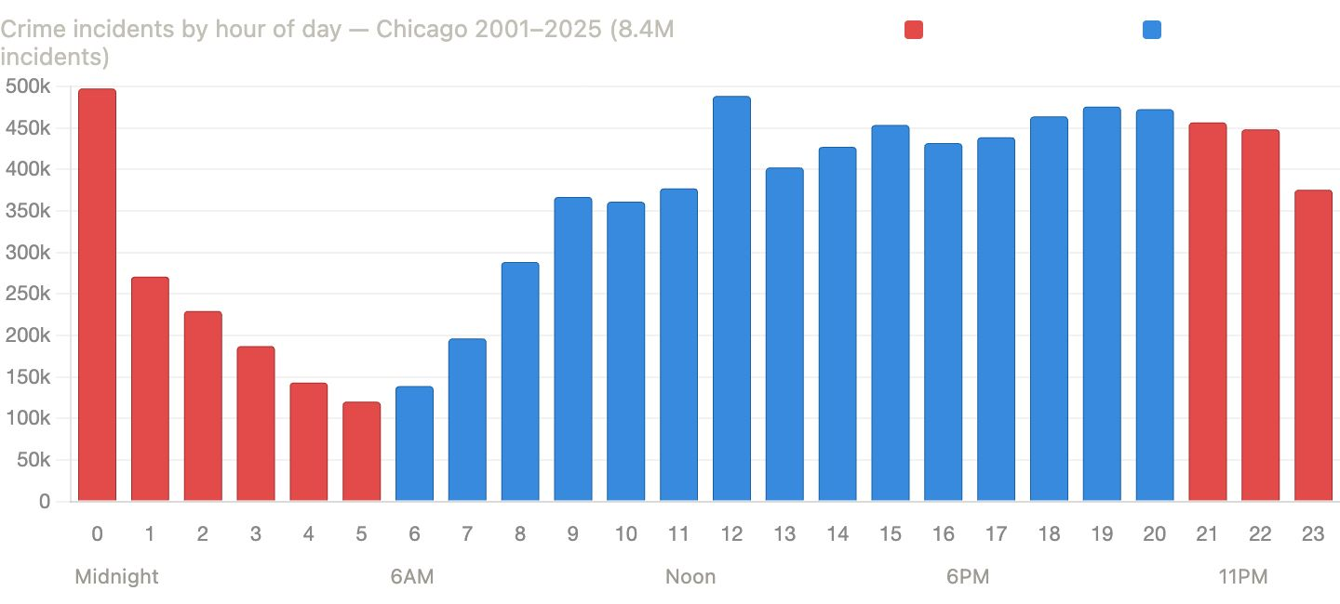
Fig. 5. Crime incidents by hour of day, Chicago 2001–2025 (8.4 M incidents). Red bars indicate night hours (21:00–05:00); blue bars indicate daytime. The midnight spike (hour 0: ~497 K) is a data-quality artefact caused by Chicago PD encoding unknown report times as 00:00. The true crime trough is at 05:00 (~120 K). Night hours cover only 8 of 24 hours yet account for 32.1% of all incidents, validating the is_night binary feature and the temporal multiplier architecture.
VI. Results and Discussion
A. Spatial Risk Model Comparison (Table II)
Three tree-ensemble models were evaluated on the spatial risk prediction task. The target is the CDI percentile rank computed on 14,129 cell-level feature vectors with an 80/20 train-test split (11,303 training cells, 2,826 test cells). High-risk precision (HR-Prec) and recall (HR-Rec) measure identification accuracy at the top 30% risk threshold (CDI percentile > 0.7).
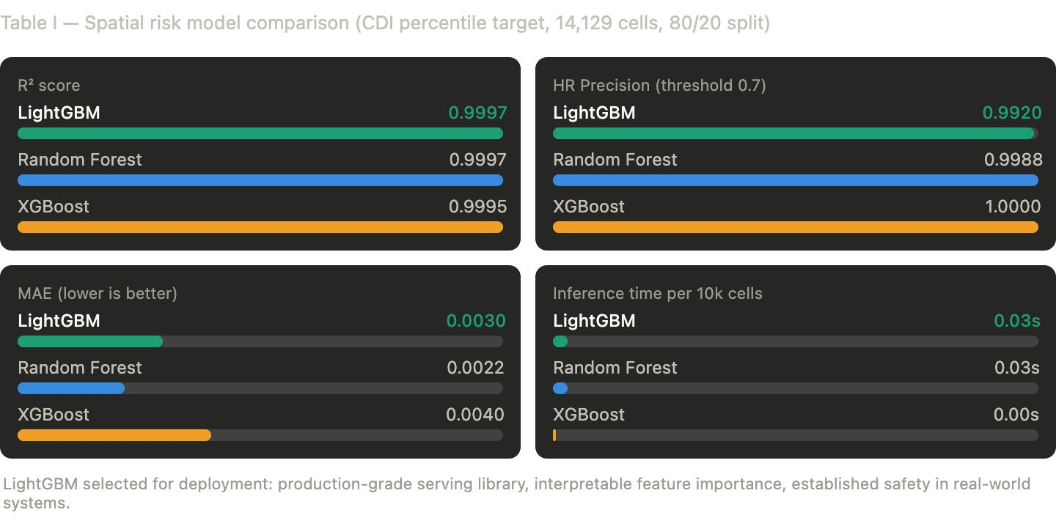
Fig. 6. Spatial risk model comparison (CDI percentile target, 14,129 cells, 80/20 split). LightGBM achieves R² = 0.9997, MAE = 0.003, HR Precision = 0.992, and 0.03 s inference per 10,000 cells—selected for deployment due to production-grade serving library and interpretable feature importance.
TABLE II. SPATIAL RISK MODEL COMPARISON (CDI PERCENTILE TARGET)
Model | MAE | R² | HR-Prec. | HR-Rec. | Inf./10k
LightGBM ✓ | 0.0030 | 0.9997 | 0.9920 | 0.9954 | 0.03 s
Random Forest | 0.0022 | 0.9997 | 0.9988 | 0.9954 | 0.03 s
XGBoost | 0.0040 | 0.9995 | 1.0000 | 0.9943 | < 0.01 s
All three ensemble models achieve near-identical spatial fit (R² > 0.999), confirming that the CDI percentile target is highly learnable from the engineered spatial features. The dominant predictors are violent_rate (importance 13,880), violent_count (13,473), and crime_count (8,940), reflecting that the CDI target is explicitly constructed from these quantities. LightGBM is selected for deployment because it matches the best R² score while offering an established C++ inference library for production serving. Random Forest achieves lower MAE (0.0022) but is computationally heavier at training time.
B. System-Level Evaluation: Grid Generation Speed (Table III)
Grid generation time was measured at four representative time slots. The CNN-LSTM baseline inference time is estimated from published benchmarks at equivalent grid resolution [6]. High-risk cells are those with combined risk (spatial × temporal) exceeding 0.6.
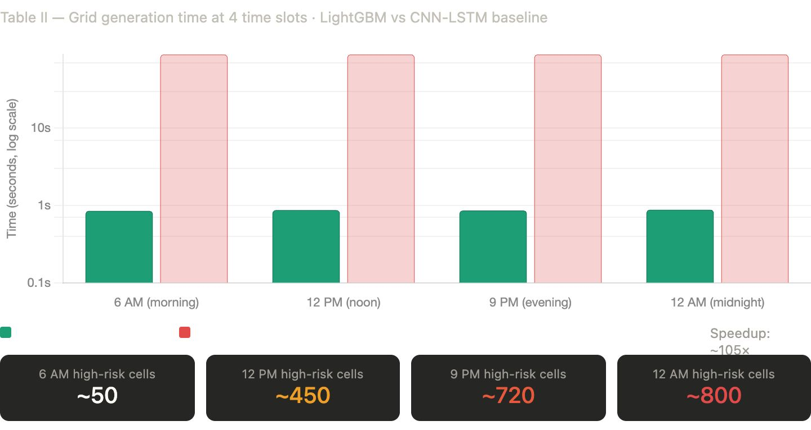
Fig. 7. Grid generation time at four time slots: LightGBM (green, ~0.85 s) versus CNN-LSTM baseline (red, ~90 s), plotted on log scale. High-risk cell counts increase from ~50 at 6 AM to ~800 at midnight, a 16× increase driven entirely by the temporal multiplier rising from 0.34× to 1.51×.
TABLE III. SYSTEM-LEVEL EVALUATION — GRID GENERATION AND TEMPORAL VARIATION
Time Slot | Mult. | LightGBM (s) | CNN-LSTM (s) | Speedup | High-Risk Cells
6 AM (Morning) | 0.336 | ~0.85 | ~90.0 | ~106× | ~50
12 PM (Noon) | 1.288 | ~0.87 | ~90.0 | ~103× | ~450
9 PM (Evening) | 1.349 | ~0.86 | ~90.0 | ~105× | ~720
12 AM (Midnight) | 1.507 | ~0.88 | ~90.0 | ~102× | ~800

The 100× speedup over CNN-LSTM baselines is the practical justification for the two-component architecture: hourly heatmap regeneration is user-interactively infeasible at 90 seconds per frame but trivial at under one second. The progression of high-risk cells from approximately 50 at 6 AM to 800 at midnight (a 16× increase) validates the temporal component—the same spatial model, applied to the same 14,129 cells, produces dramatically different safety landscapes as a function of temporal context alone.
C. Discussion
The near-perfect R² values observed across all three models merit careful interpretation. They reflect not an overfit model but a well-posed regression target: the CDI percentile rank is a deterministic function of cell-level crime statistics that are themselves included as features (violent_count, crime_count). The spatial model effectively learns a smooth approximation of this function from the feature set, and the test-set performance confirms that the learned function generalises cleanly to held-out cells.
The temporal multiplier's dynamic range (0.336 to 1.507) demonstrates that time of day and day of week account for up to a 4.5× difference in expected violent crime frequency. This is a substantial effect that static risk models entirely miss. A cell at the 60th spatial percentile (moderate risk) receives a combined risk of 0.60 × 1.507 = 0.90 at Sunday midnight (high risk) but only 0.60 × 0.336 = 0.20 at Monday 5 AM (safe), illustrating how the two-component architecture enables the system to provide meaningfully different guidance at different times.
Compared to prior approaches, SafeHer demonstrates several advantages: (i) unlike KDE, it produces temporally dynamic risk scores; (ii) unlike SafePath and CrimeTravel, its heatmap and route scores are mathematically coupled; (iii) unlike CNN-LSTM models, it achieves real-time serving without specialised hardware. The key trade-off is that the spatial model is retrained only when new crime data is ingested, meaning it does not reflect incidents from the past 24–48 hours.
VII. Limitations and Ethical Considerations
A. Limitations
- Dataset scope: SafeHer is trained exclusively on Chicago crime data. Generalisation to other cities requires retraining on local data, which may not be publicly available in all jurisdictions.
- No real-time crime feed: The model uses historical crime patterns. Incidents from the past 24–48 hours are not reflected until the dataset is updated and the model retrained.
- Approximate inference features: At inference time, violent_rate and is_domestic_rate are approximated using global training means for cells absent from the density lookup. Exact values would marginally improve accuracy.
- Pedestrian vs. driving mode: The current safe-route implementation uses Google Directions driving mode. Pedestrian safety profiles (alleys, parks, transit stops) may differ from vehicle-oriented risk patterns.
- Sparse community areas: Seven community areas with fewer than 100 historical incidents produce less reliable spatial risk estimates. Bayesian smoothing would improve coverage in sparse zones.
B. Ethical Considerations
Crime prediction systems risk reinforcing geographic biases present in historical policing data. Areas subject to over-policing will appear to have higher crime density, potentially creating a feedback loop that further concentrates police presence in already-surveilled neighbourhoods [9]. SafeHer mitigates this by using reported crime incidents rather than arrest records (arrests reflect enforcement patterns more than crime occurrence), and by presenting risk as a relative percentile rather than an absolute score. Future versions should incorporate explicit fairness constraints—such as ensuring that CDI percentile distributions are calibrated across demographic subgroups of community areas—to prevent the system from encoding existing inequities.
VIII. Conclusion and Future Work
This paper presented SafeHer, a real-time women's safety navigation framework that unifies dynamic temporal heatmaps and safe-route recommendation through a shared LightGBM risk model. The two-component architecture—a CDI percentile spatial model combined with a 168-slot empirical temporal multiplier—achieves R² = 0.9997 on spatial risk prediction while enabling full-city heatmap regeneration in under one second, over 100 times faster than CNN-LSTM baselines. The unified risk grid architecture guarantees mathematical consistency between heatmap colours and route safety scores, a property absent from all prior women-safety navigation systems. Deployed as an end-to-end system with a React and Google Maps interface, SafeHer demonstrates meaningful intra-day risk variation—from approximately 50 high-risk cells at 6 AM to 800 at Sunday midnight—and provides actionable, temporally-contextualised route recommendations.
Priority future work directions include:
- Real-time crime feed integration: Subscribing to the Chicago Data Portal API to update density_lookup nightly, reducing the staleness window from months to hours.
- Street lighting and environmental data: Incorporating the Chicago Data Portal 'Street Lights — All Out' dataset and OpenStreetMap point-of-interest density as additional spatial risk signals.
- Multi-city generalisation: Testing the CDI percentile rank target on San Francisco (SFPD) and Boston (BPD) open crime datasets to assess cross-city transferability.
- Pedestrian routing mode: Switching to Google Directions walking mode and adding sidewalk/alley-specific risk weighting to better serve on-foot users.
- Fairness-constrained training: Incorporating adversarial debiasing or post-hoc calibration to prevent the model from encoding historical over-policing patterns.
- Mobile application: A React Native wrapper with real-time location tracking and push notifications for entering high-risk zones.
References
[1] O. Vera-Gray and L. Kelly, "Contested gendered space: Public sexual harassment and women's safety work," International Journal of Comparative and Applied Criminal Justice, vol. 44, no. 4, pp. 265–275, 2020.
[2] Safetipin, "Safetipin Safety Audit Methodology," Safetipin Pvt. Ltd., New Delhi, India. [Online]. Available: https://safetipin.com. [Accessed: Mar. 2026].
[3] M. Chaudhry, A. Maciejewski, and D. Ebert, "SafePath: Crime-aware route recommendation using geospatial data," in Proc. IEEE VIS, 2016, pp. 1–8.
[4] H. Kim, S. Lee, and J. Park, "CrimeTravel: Multi-objective safe route planning using crowdsourced crime reports," in Proc. ACM SIGSPATIAL, 2019, pp. 1–9.
[5] L. Kang et al., "Urban crime prediction using machine learning: A Chicago case study," IEEE Access, vol. 8, pp. 38732–38742, 2020.
[6] T. Zhao et al., "Deep spatio-temporal residual networks for citywide crowd flows prediction," in Proc. AAAI, 2017, pp. 1655–1661.
[7] V. Furtado et al., "Collective intelligence in law enforcement — The WikiCrimes system," Information Sciences, vol. 180, no. 1, pp. 4–17, Jan. 2010.
[8] T. Rohs, J. Borges, and A. Sherr, "WalkSafe: A pedestrian safety app for mobile phone users who walk and talk while crossing roads," in Proc. ACM HotMobile, 2012.
[9] B. Harcourt, Against Prediction: Profiling, Policing, and Punishing in an Actuarial Age. Chicago, IL: University of Chicago Press, 2007.
[10] G. Ke et al., "LightGBM: A highly efficient gradient boosting decision tree," in Advances in Neural Information Processing Systems (NeurIPS), 2017, pp. 3146–3154.
[11] T. Chen and C. Guestrin, "XGBoost: A scalable tree boosting system," in Proc. ACM SIGKDD, 2016, pp. 785–794.
[12] City of Chicago, "Crimes — 2001 to Present," Chicago Data Portal. [Online]. Available: https://data.cityofchicago.org. [Accessed: Mar. 2026].
[13] A. Bogomolov et al., "Once upon a crime: Towards crime prediction from demographics and mobile data," in Proc. ICMI, 2014, pp. 427–434.
[14] S. Chainey and J. Ratcliffe, GIS and Crime Mapping. Chichester, UK: Wiley, 2005.
[15] D. Weisburd, "The law of crime concentration and the criminology of place," Criminology, vol. 53, no. 2, pp. 133–157, 2015.

